No. 41 – Hebrew letters
- Rashi (Ophir & Avrin 1993: 67)
- Square (Fishman 2001: 30)

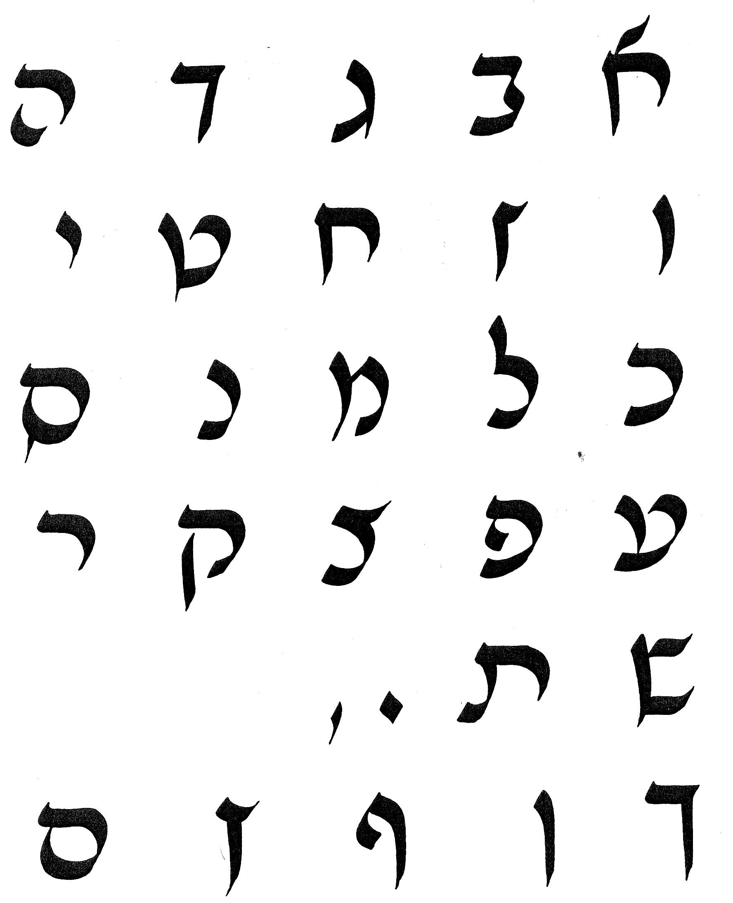

Rashi

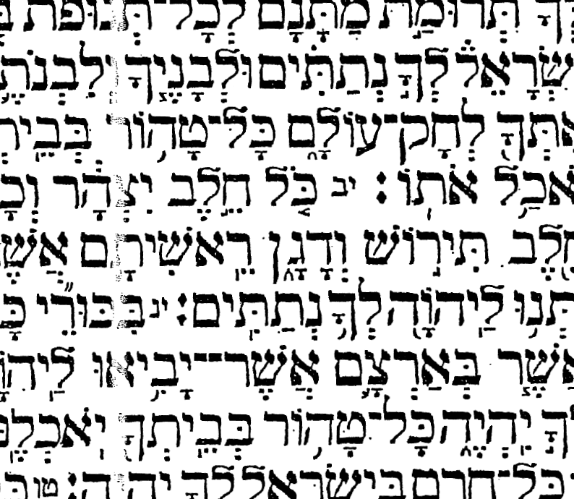

Square

No. 42 – Arabic calligraphy (Zakariya 1979: 18, 25, 30, 31)
- Kufic
- Naskhi
- Nastaliq
- Maghribi

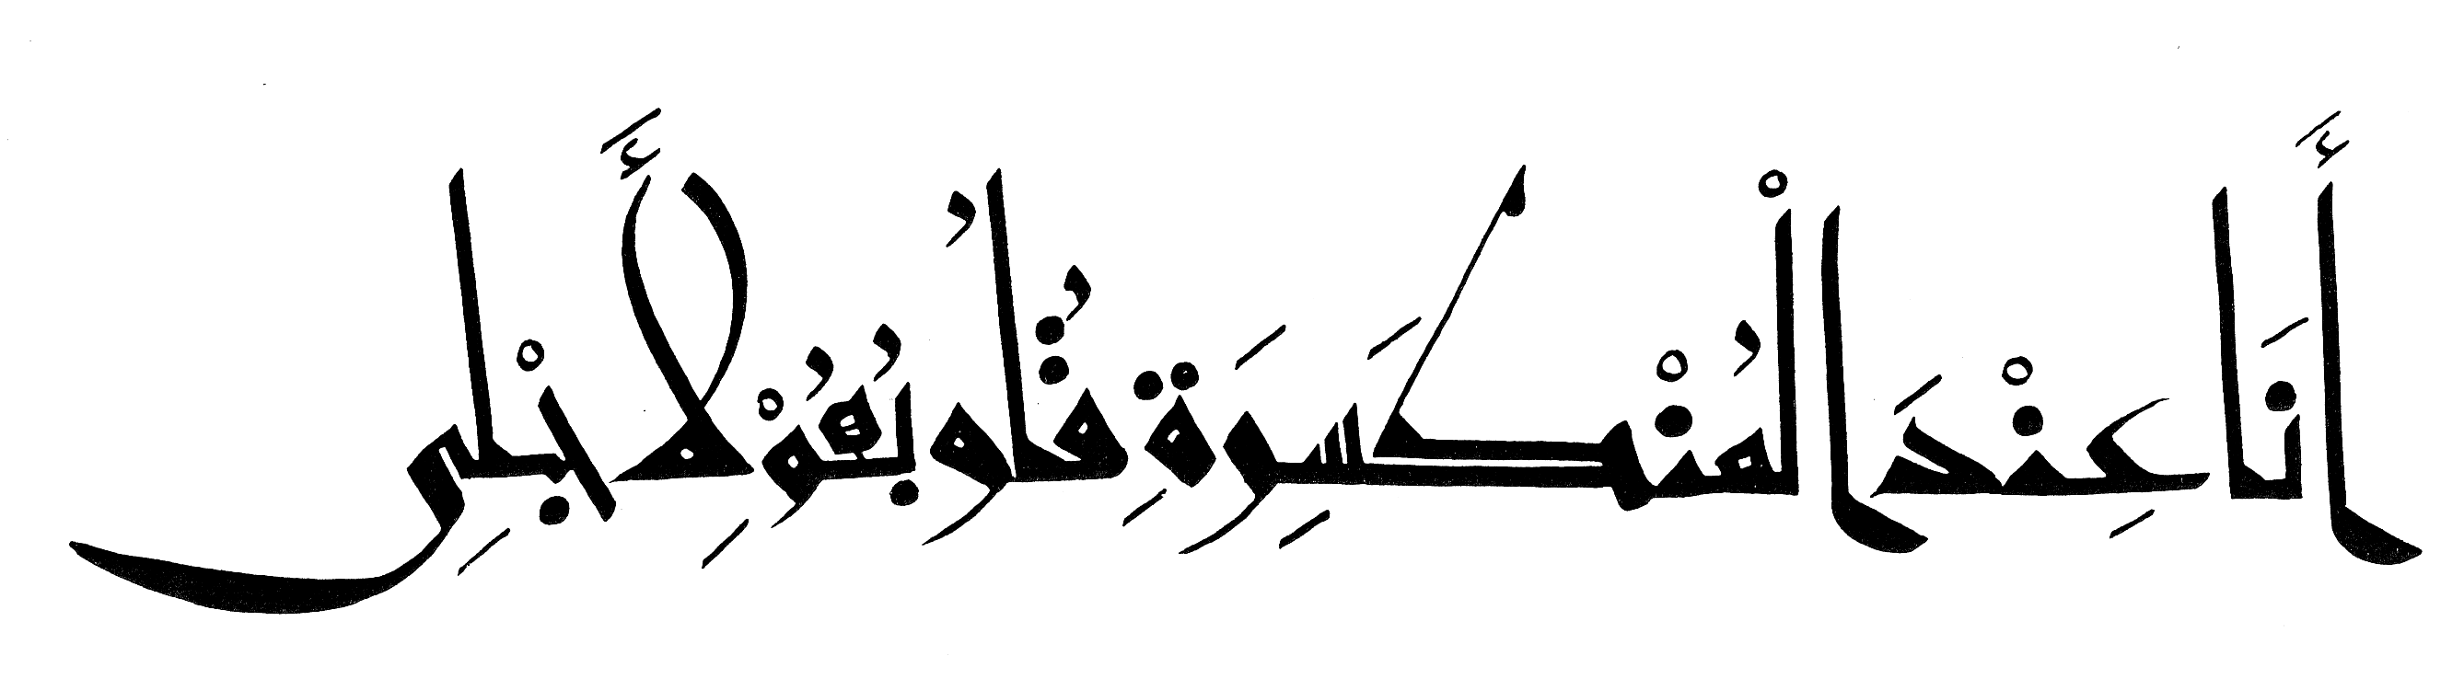
Eastern Kufic

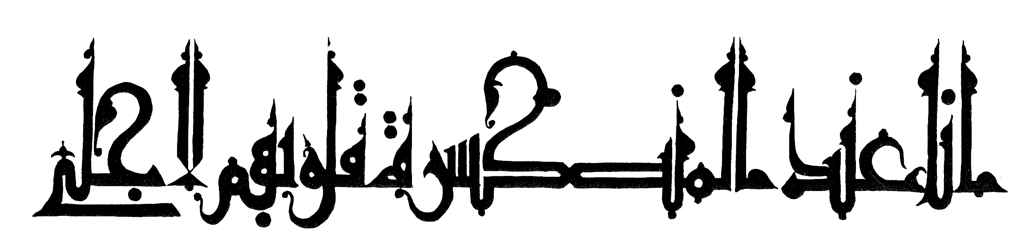

Drawn Kufic

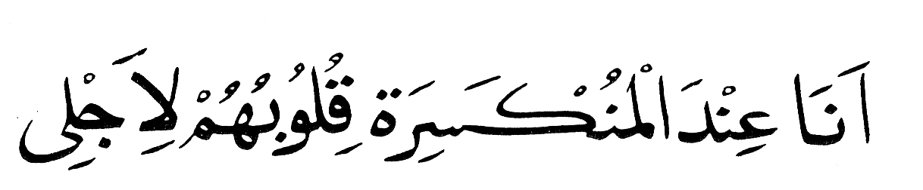

Naskhi

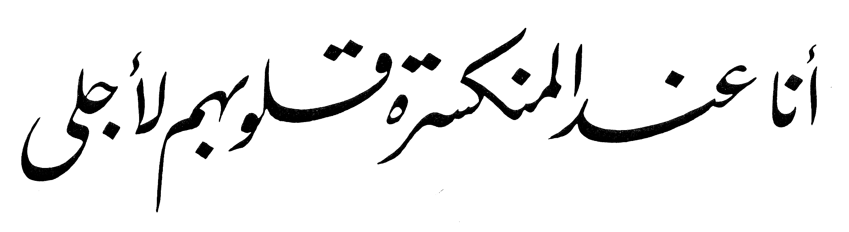

Nastaliq

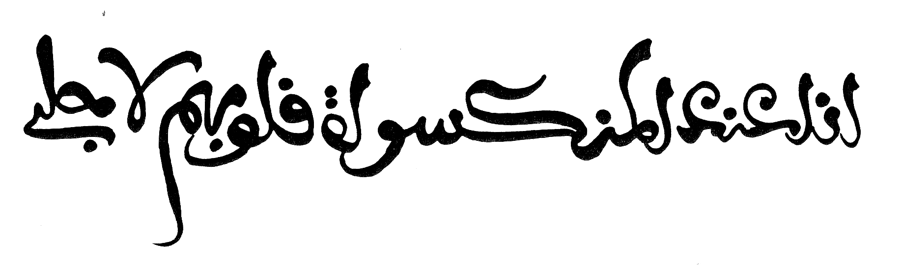
Maghribi

