How Similar (and Different) Are European Languages
In 1971 Dr. Morris Swadesh published a list of 100 words. The list, which he had worked on for more than 20 years, contained the most universal and common words used in languages, and was intended to quantify the interrelatedness of languages. The words on the list also appeared to be very stable having existed for thousands years.
Since then linguists have produced some more modern and accurate lists of common words, but the Swadesh List remains the most widely-used.
The Swadesh List helps us to find the cognates – words in languages that have the same roots. Like father in English, which comes from Latin pater, which is Vater in German and padre in Spanish. You don’t have to be a linguist to find the cognates with this list!
Showing the words on mapa makes is a way to see the interrelatedness between the European languages, and to see the language families as well. For some countries though you have to know the Cyrillic alphabet.
Let’s start comparing!
I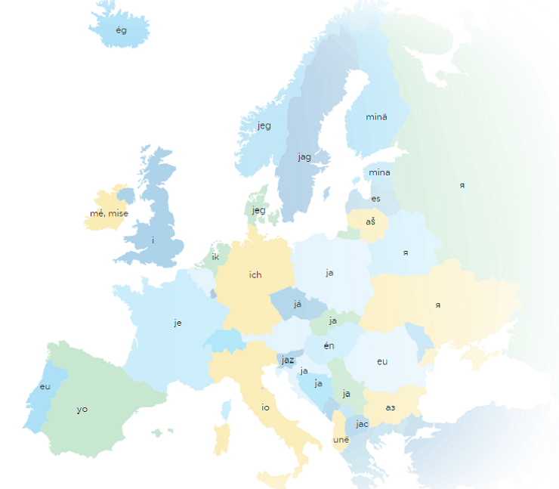

You
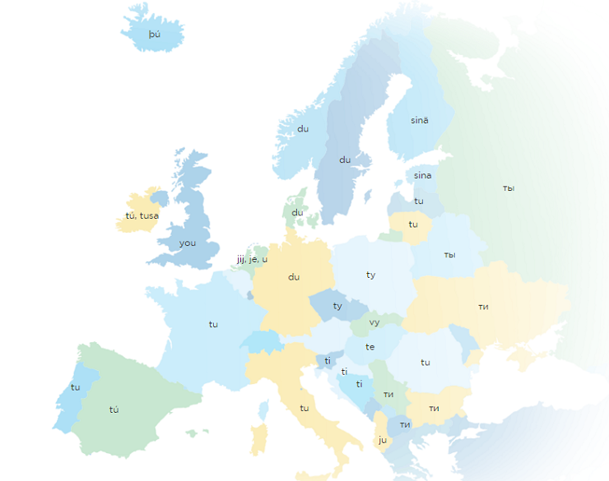

One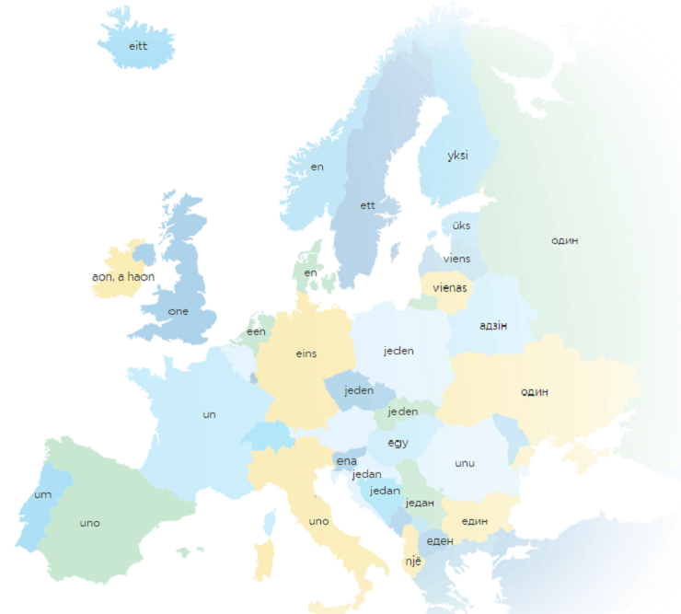

Man 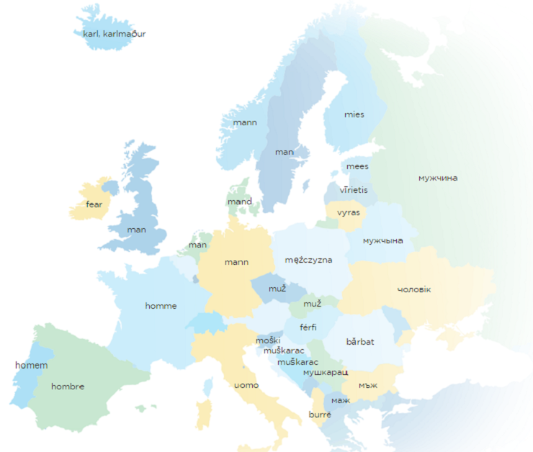

Man (Person) 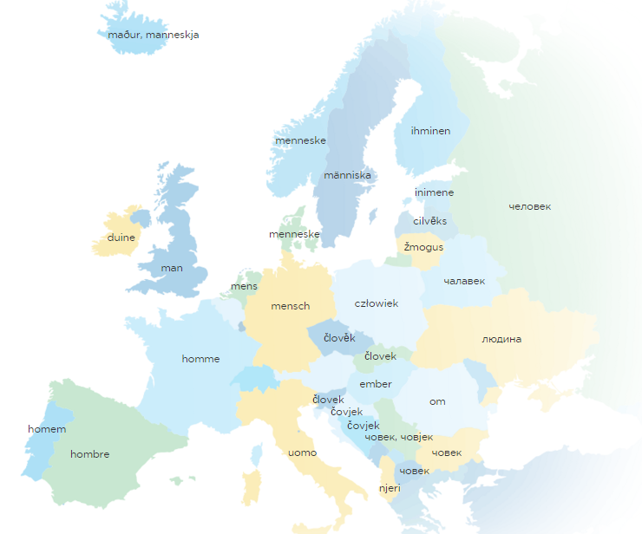
Mother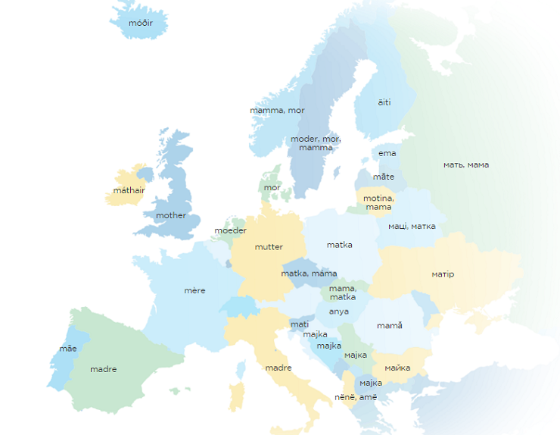
Father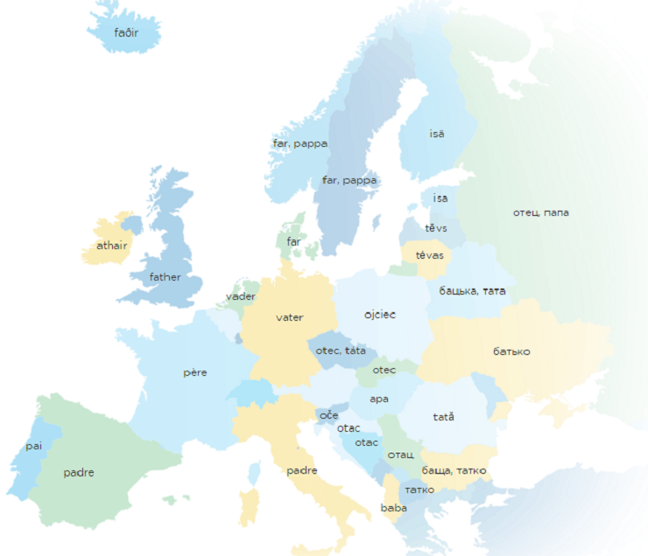

Tree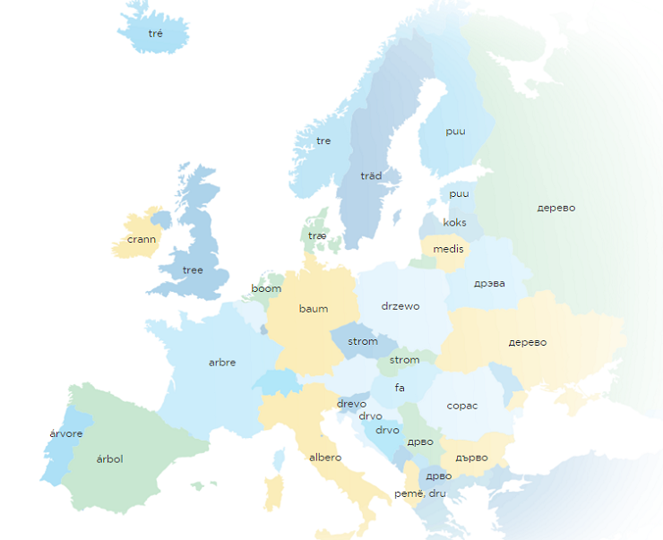

Meat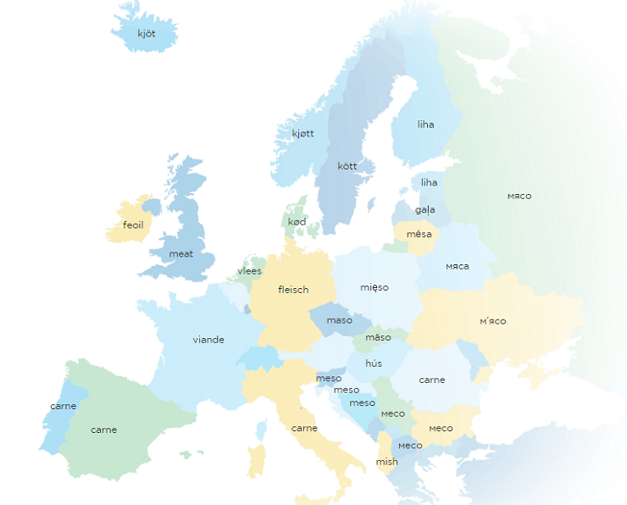

Blood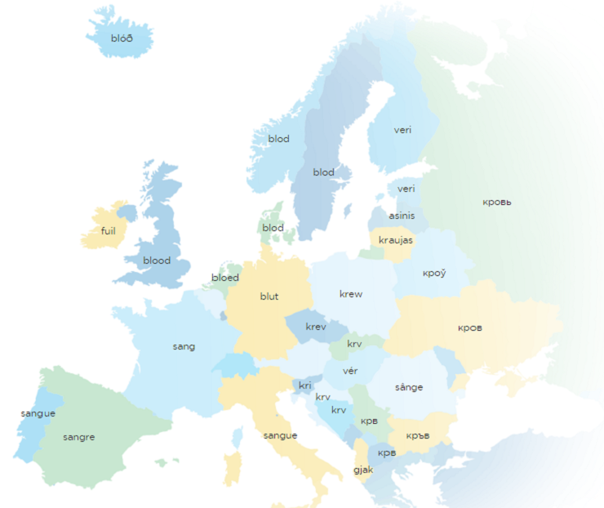

Egg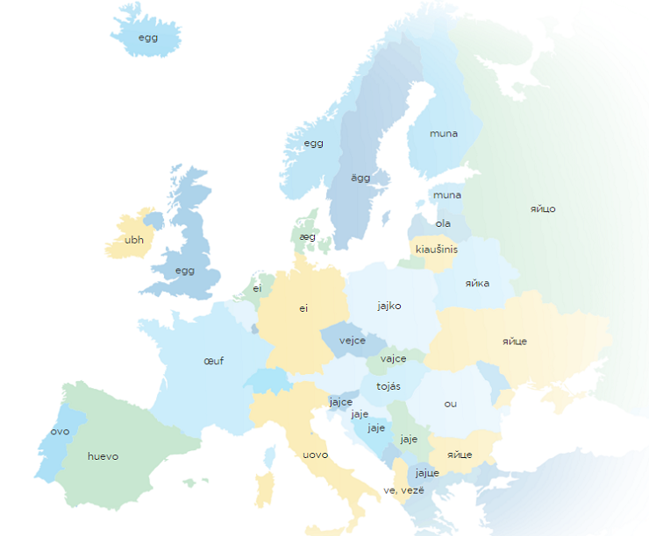

Eye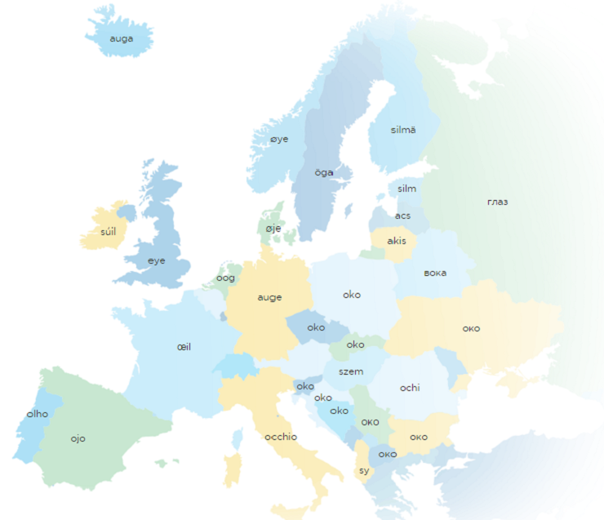

Nose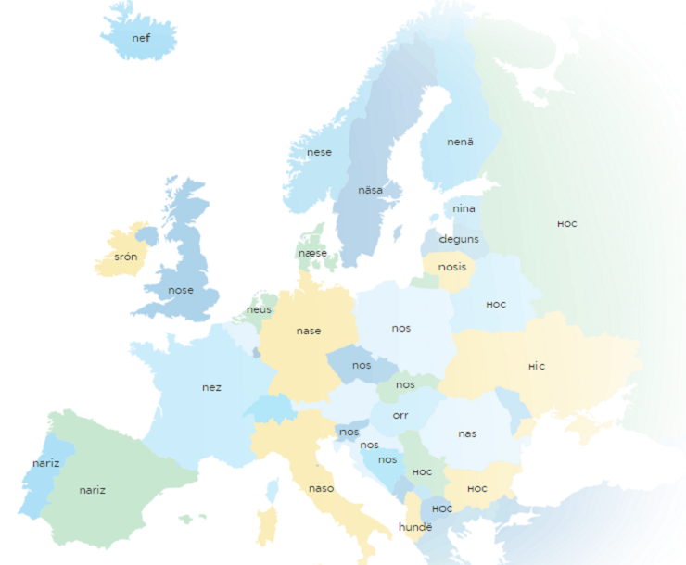
Heart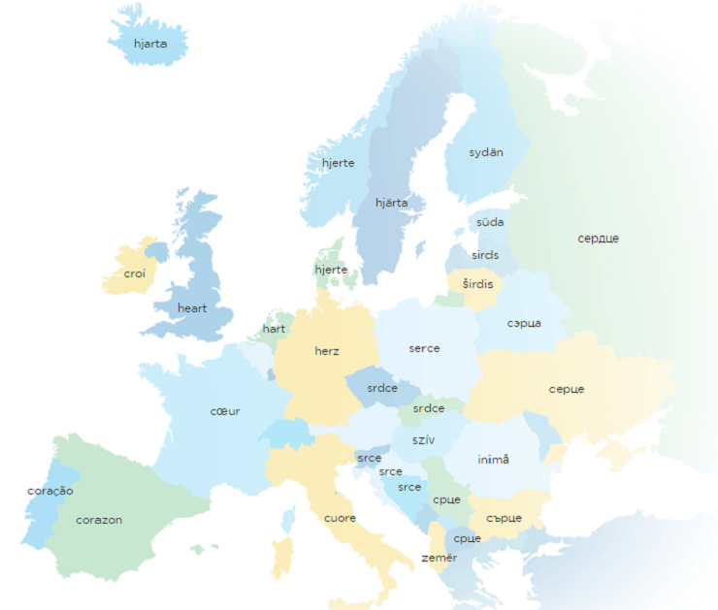

Eat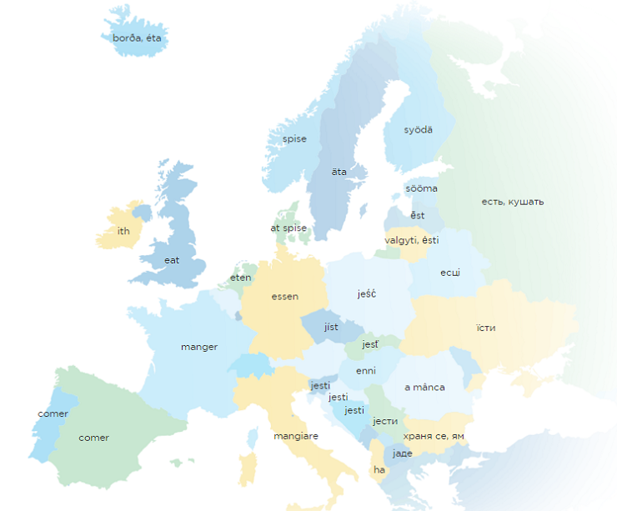

Live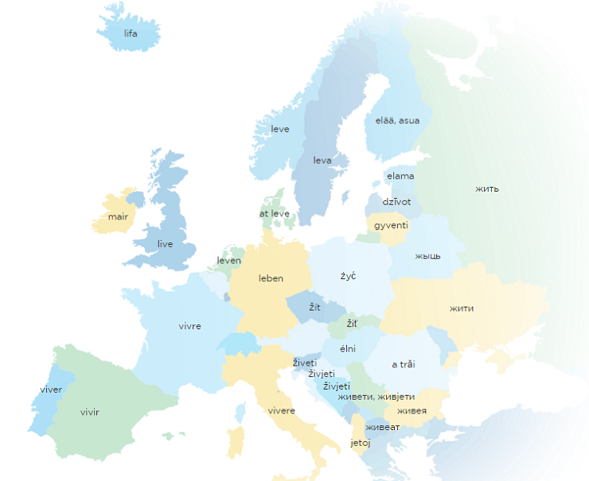

Die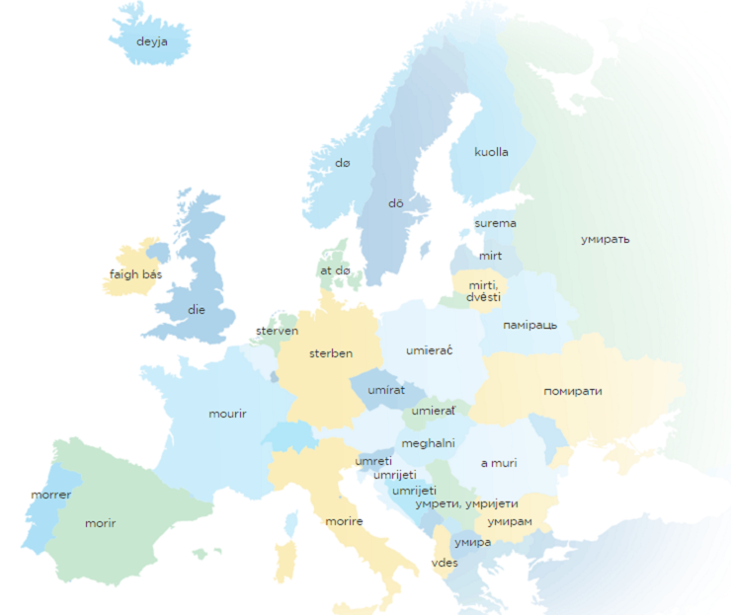

Water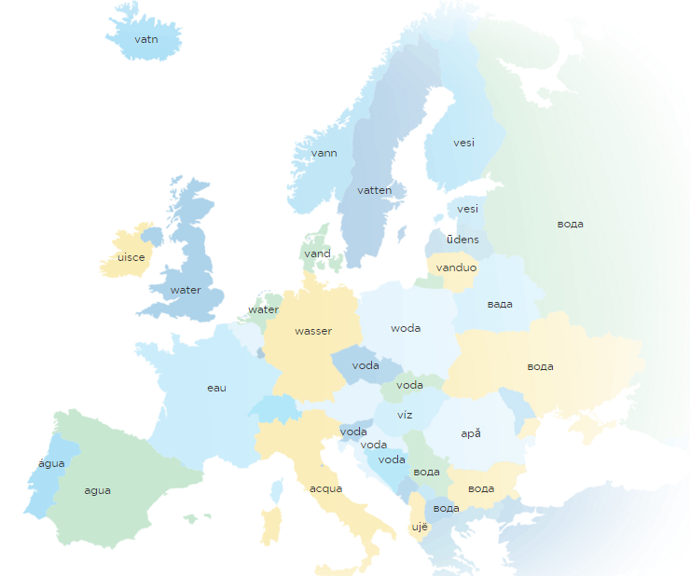

Earth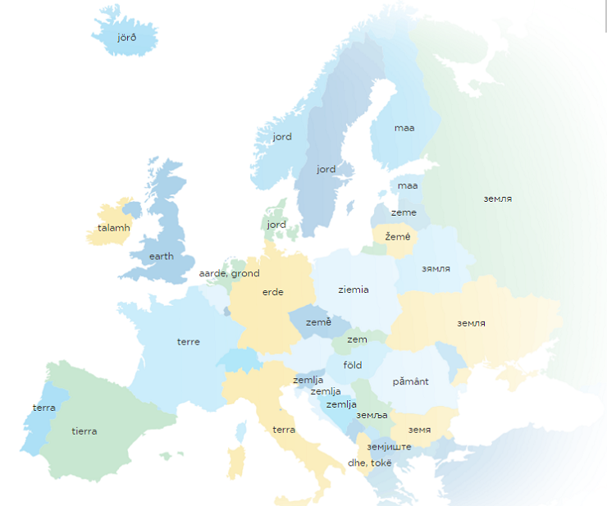

Sky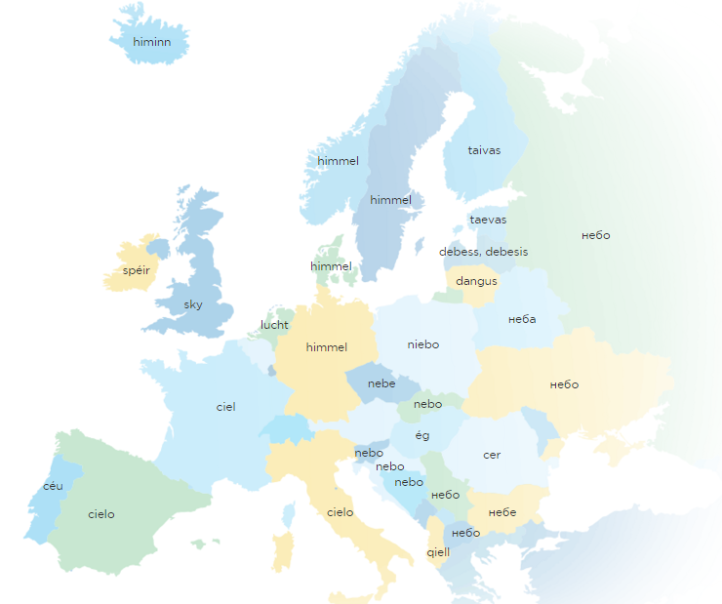

Fire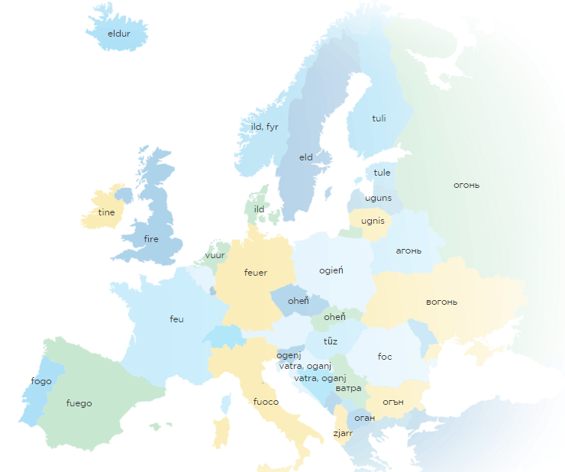

Red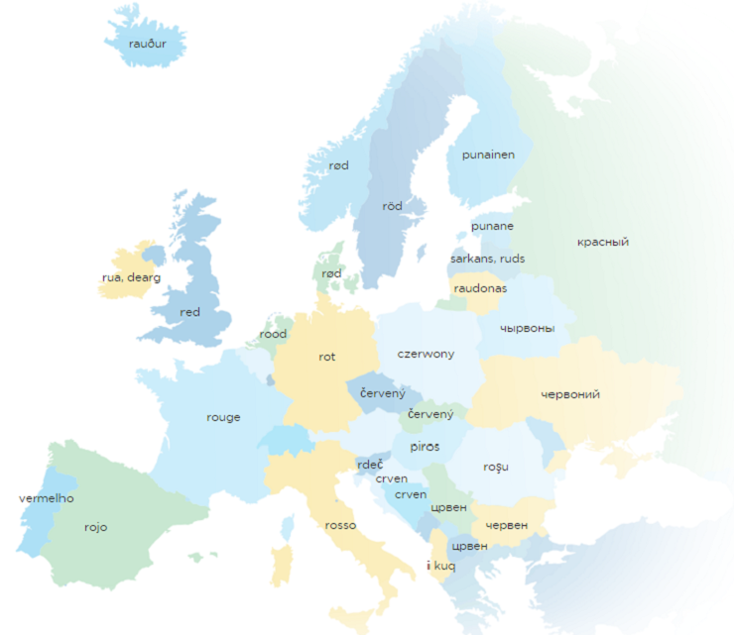

Green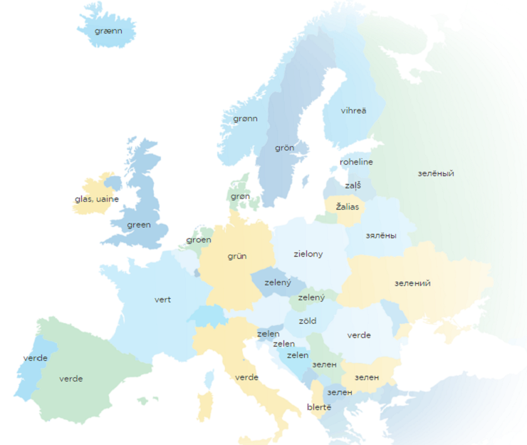

Yellow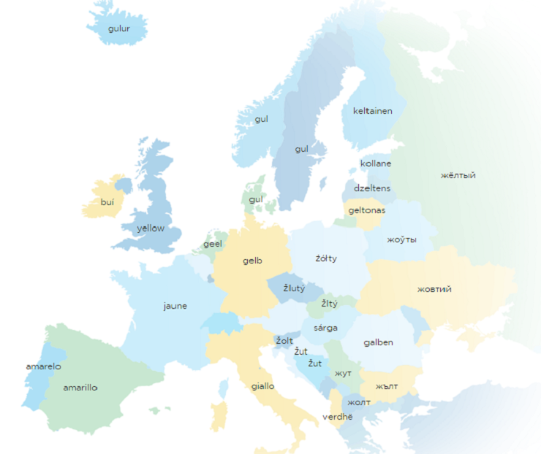

White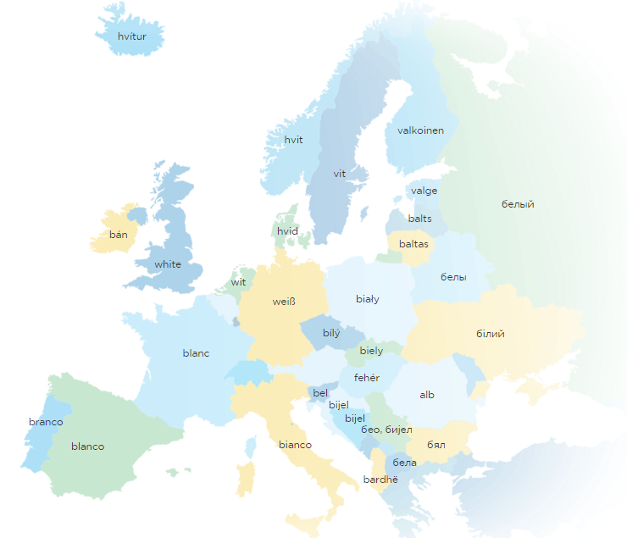

Black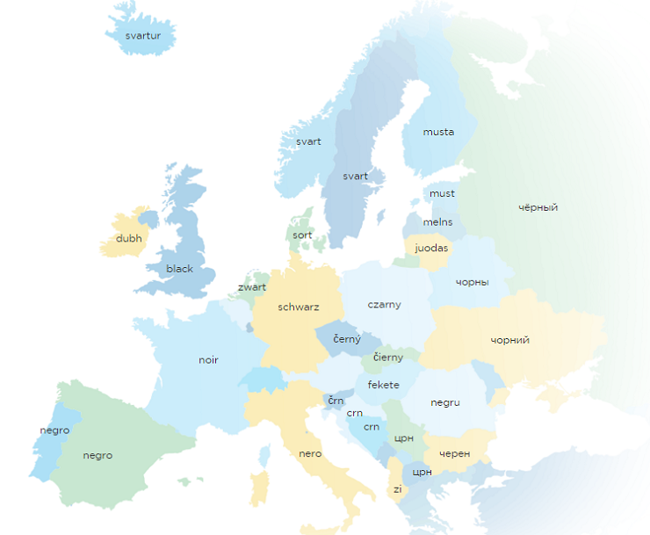

Name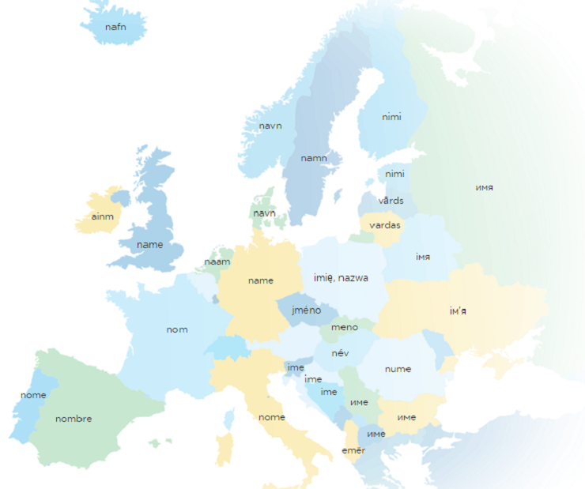

Good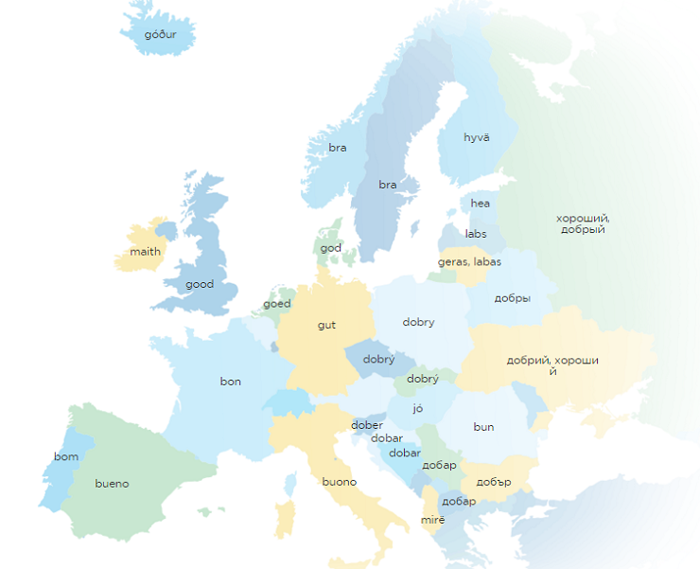

Bad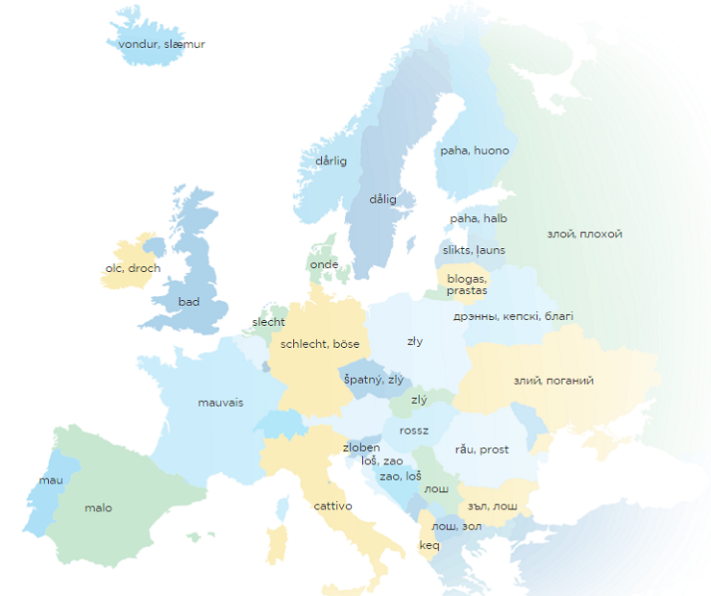

About the Author:
Nicole Stansley is a digital strategist for Write My Essay For Me and a freelance writer. Her area of interests includes, though not limited to learning, writing, self-development and motivation topics.

