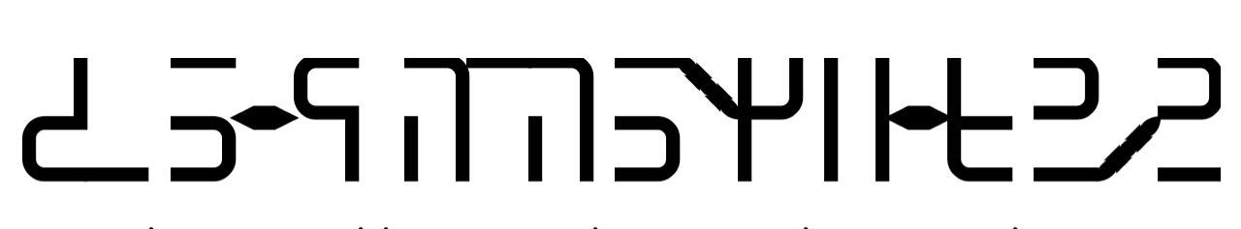
Sulat Hiligaynon
Sulat Hiligaynon was invented by Julius Alfred Cordova of Iloilo City in the Philippines as alternative to write Hiligaynon, which is spoken in the Western Visayas region of the Philippines by about 9 milllion people and is the fourth most spoken language in the Philippines. It is usually written with the Roman/Latin alphabet.
Notable Features
- Type of writing system: featural alphabetic syllabary
- Writing direction: from left to right
- Used to write: Hiligaynon
Consonants
 | bilabial |  | alveolar |  | velar |  | palatal |  | glottal
nasal |  | m |  | n |  | ñ |  | N |  | -
 |  | m |  | n |  | ng |  | ni/ny |  | zero
 |  | [m] |  | [n] |  | [ŋ] |  | [ɲ] |  | consonant
stop | p | b | t | d | k | g | T | D | q
 | p | b | t | d/r | k | g | ti | di | '
 | [p] | [b] | [t] | [d/ɹ] | [k] | [ɡ] | [c] | [ɉ] | [ʔ]
fricative /  approximant | P | B | s | r | K | G | S | y | h | w
 | pi | bi | s | r | ki | gi | si/sy | y | h | w
 | [pʲ] | [bʲ] | [s] | [r] | [kʲ] | [ɡʲ] | [ɕ] | [j] | [h] | [w]
lateral  approximant |  | m | R | l |  | Ñ | c | L | H | j
 |  | mi/my | ri/ry | l |  | ng/y | ch | li/ly | hy | j
 |  | [mʲ] | [ɾʲ] | [l] |  | [ŋʲ] | [tɕ] | [ʎ] | [hʲ] | [dʑ]

Vowels and suprasegmentals
 | a | i | u | e | o
monophtohongs | qa | qi | qu | qe | qo
 | a | i | u | e | o
 | [ʔa] | [ʔi] | [ʔu] | [ʔe] | [ʔo]
diphthongs | -' | qay | qaw | qew | qoy
 | zero | ay | aw | ew | oy
 | vowel | [ʔaɪ] | [ʔaʊ] | [ʔeʊ] | [ʔoɪ]
glottal stop | qaq | qiq | quq | qeq | qoq
 | à | ì | ù | è | ò
 | [ʔaʔ] | [ʔiʔ] | [ʔuʔ] | [ʔeʔ] | [ʔoʔ]
stress | qah | qih | quh | qeh | qoh
 | á | í | ú | é | ó
 | ['aʔ] | ['iʔ] | ['uʔ] | ['eʔ] | ['oʔ]

Writing rules and special features
Syllabification
- Each syllable is only consist of two or three phonemes (including the glottal stop); onset (consonant), nucleus (vowel) and coda (consonant). Eg. a (V), ba (CV), ag (VC) and bag (CVC).
- Syllabication is based from word morphology, this means affixes are written in separate blocks. Eg. na–ga–bul–ú–lig–ay and mag–ul–ú–tod.

Patalal and palatalized consonants
- Palatal and palatalized consonants are considered as distinct phonemes in Hiligaynon. Eg. mi/my [mʲ] - miaw, a–myon; pi [pʲ] - piang–kà, ka–piot; bi - [bʲ] biom–bo, a-bian; ni/ny [ɲ] -nia, i–nyo; ti [c] - tia–ngaw, ba–tiag; di [ɟ] - dio–tay, ka-dios; si [ɕ] - sia–git, ba–siaw; ch [tɕ] - kat–chu–bong, kat–chu–rì; ngy [ŋʲ] - sa–ngyad, bu–ngyod; ki [kʲ] - kiaw, ba–kià; and ɡi [ɡʲ] - gio–han–an and ba–gio.
- Ry/ri [ɾʲ] and ly/li [ʎ] are marginal consonants of Spanish origin. Eg. Ryu–jin, pe-rya, liem–po and ka-lye.
- Ch [tɕ] becomes geminated if the preceding syllable has no coda. Eg. kut–chi–lyo, kat–cha, plan–cha and man–cha, . The ch of Hiligaynon is the same with the ch of Korean and Japanese.
- If ch is followed by another ch in the next syllable it's not geminated. Eg. chi–cha–ron, cha–cha and chi–chi–rya.
- Y [j] is also a palatal consonant. Eg. yam–bì, yu–hóm, sú–yà, bá–yò.
- There is no j [dʑ] in Hiligaynon but this letter is very necessary in writing foreign words. Eg. Joy, Jen–nie (Jen–ni), Hee–jin (Hi–jin) and Kyu–jin. (Gyu–jin). The j of Hiligaynon is the same with the j of Korean and Japanese.
- Hy [hʲ] is also added to complete the palatal and palatalized consonants. Eg. Hye–won, Hyun–jin (Hyon–jin), Chae–hyun (Che–hyun) and Ji–hyo.
Glottal stop [ʔ]
- Glottal stop is usually found in the coda of a final syllable. Eg. dú–tà, bá–lì and pú–lò.
- An initial syllable of a word without an onset actually has a glottal stop. Eg. a–kó, i–káw and u–sá.
- There is also a glottal stop between two consecutive vowels. Eg. ba–ól, pí–od and tú–ad.
- The hyphen in some words functions as a glottal stop. Eg. tul–an, hal–id and pat–od.
- Some repeated syllables have also a glottal stop. Repeated syllable is pronounced the same. Eg. dà–dà, sì–sì and bù–bò. The o in bù–bò is actually pronounced as [u] so it's written as a u.
- Foreign words can also have a glottal stop. Eg. man–te–kà, kan–de–là, Yu–jù and Min–jù.
Glottal fricative [h] as a stress symbol
- H can be used a stress symbol in the coda of a syllable. Eg. sá–là, dí–là, pú–gà, si-lá, bi-lí and kukó.
- If the initial syllable of a word is unstressed that means the stress is in the final syllable. Eg. tu–pád, ba–lík and su–lód
- A word cannot be stressed if the initial syllable has a coda. Eg. bun–law, til–tig and suk–mat.
- Words with palatal or palatalized consonant in the initial syllable also cannot be stressed. See Palatal and palatalized consonants for examples.
- Repeated syllables can be stressed but it's unnecessary. Repeated syllables are pronounced the same. la–la, Mi–mi, ku—kó, and Be–be and Mo–mo. The o in kú–kó is pronounced as [u] so it's written as a u.
- Repeated syllables can have a coda but again stress is unnecessary. Eg. ta–ták, bi–bíg, tu–tóy, ne–nè, to–tò. The o in tu–tóy is pronounced as a [u] so it's written as a u.
- Stress is only apply to the root words, this means affixes has no stress. A word can only have one stress. Eg. ka–ú–tor–an and bul–ú–hat–on
- If the final syllable has both glottal stop and stress only the glottal stop is written. It is understood that final syllable has a stress if the initial syllable is unstressed. Eg. ba–kâ, ti–kî and du–kô.
- H can be also used in expressions. Eg. ah, eh and oh.
Approximant r [ɹ] and flap r [ɾ]
- Approximant r is an allophone of d. It has the same symbol as d. Eg. lá–pad + -i = lá-par–i and lu–pád + -a= lu–par–a.
- Flap r is not an allophone of d. It has its own symbol. Eg. ra–bó, rí–mis, rum–bo, sa–ráng, bi–ríng and tá–rong
Consonant clusters
- Hiligaynon lacks consonant cluster. Consonant clusters are usually found in foreign words. Consonant clusters usually has r or l. If the consonant cluster is in the onset of the initial syllable it preceded by a zero consonant and a zero vowel. Eg. p–ri–to, kru–do, p–la–sa and k–la–se.
- If the cluster consonant is in the next syllable they are written separately but pronounced together. Eg. lit–ro, me–tro, diab–lo and lib–ro.
- In native Hiligaynon words there are false consonant clusters. It occurs when the preceding syllable has a coda and the onset of the next syllable has a r or l. They are written and pronounced separately. Eg. sap–rat, tup–ra, dup–là and tuk–lò.
- If consonant clusters is in the coda of a syllable it's ended by a zero vowel. Eg. lam–p, san–d, tan–k and mol–d. The n in tank is pronounced as ng [ŋ]. It is an allophone of n so it's written as n.
Labio-velar approximant [w]
- There are no velarized consonants in Hiligaynon but if semi-vowel w is preceded by a consonant it is written like a consonant cluster. Eg. p–we–de, b–we–nas, s–wer–te and r–we–da.
- This is also applied to the next syllable. Eg. ban–wa, las–wa, bak–wa and al–wan. They are also written separately but pronounced together.
Zero consonant
- Zero consonant is usually use as an onset in suffixes. Eg. bú–lig–an, ká–on–on and tu–lók–ay.
- There is also a zero consonant after infixes. It is written in the onset of the next syllable. Eg. dum–a–an, kin–a–on and bal–a–lik. The -um-, -in- and -al- are the infixes.
- Semi-vowels w and y are written as a zero consonant if preceded by vowels u and i respectively. Eg. lu–was, gu–wâ, pi–yong and bi–yà.
- Zero consonant is also used if e and o are followed by a vowel. Eg. Be–a, Le–o, No–ah and Ro–el.
- Zero consonant can be used in the beginning of a syllable if the reading of next word is joined with the preceding word. Eg. ah-ah, eh-eh, oh-oh. In contrast with ah ah, eh eh and oh oh that glottal stop is used.
Vowels
- There are only five native vowels in Hiligaynon; a, i, u, e and o. E and o are usually found in the final syllables. Eg. bá–lì, li–tík, pu–tî, bá–yò, pí–to and tu–yó. The i in ba–lì, li–tík and pu–tî is actually pronounced and written as an [e].
- The pronunciation and spelling of final e and o are not changed even if added with a suffix. Eg. ba–lík + -an = ba–lík-an and tú–lok + –a = tú–lok–a. The i in ba–lík–an is still pronounced and write as an [e].
- E and o in intial and medial syllables are usually found in foreign words. Eg. e–kis, re–ló, bang–ke–te, mi–tér, o–ras, ko–si–na and ka–hón, mier–ko–les. If there is only an e or o in the initial syllable the word can be stressed but it's unnecessary.
- There are no yi and wu syllables in Hiligaynon, they become ye and wo respectively. Eg. Ye–na, Ba–hi–yyih (Ba–hi–ye) Won–young (Won–yong) and Chae–won (Che–won).
- Even though there are only five native vowels but they have allophones. [æ], [ɪ], [ʊ], [ɛ] and [ɔ] are used when the coda of a syllable is voiceless consonant. These allophones are also applied to unstressed syllables.
- Vowels become centralized if the syllable is stressed.
Diphthongs
- Diphthongs are witten as semi-vowels; aw, ay, ew and oy. Eg. ad–law, ba–láy, liw–as, buy–on, man–tyo and ba–boy. The yo in man–tyo is written as ew, it's an allophone and not palatalized. Ew and oy are written and pronounced as iw and uy respectively in the initial syllable.of words.
- There are no ey and ow diphthongs in Hiligaynon. They are usually found in foreign words. Eg. cake (key–k), make (mey–k), bone (bow–n) and cone (kow–n).
Zero vowel
- Zero vowel is usually used in contracted words. Eg. gu–bâ + a = gu–b–a and su–lod + i = su–d'l–i.
- Zero vowel is also used in consonant clusters. See Consonant clusters for examples.
Writing down Sulat Hiligaynon using Hiligaynon keyboard
Corresponding letters
- m – m, p – p, b – b, mi or my – M, pi – P and bi – B
- n – n, t – t, d – d, t – t, ni or ny – N, ti – T and di – D
- s – s, r – r, l – l, si or sy – S, ri or ry – R and li or ly – L
- ch – c and j – j
- ng – ñ, k – k, g – g, ngy – Ñ, ki – K and gi – G
- y – y and w – w
- h – h, hy – H and glottal stop – q
- a – a, i – i, u – u, e – e and o – o
- à – à, ì – i, ù – ù, è – è and ò – ò
- á – á, í – í, ú – ú, é – é and ó – ó
- zero consonant – hyphen (-) and zero vowel – apostrophe (')
Spacing
- Press space once every after syllable and press space twice every after word.
- Press space twice after stressed syllable or when a syllable has a glottal stop in the coda.

Sample text in Sulat Hiligaynon
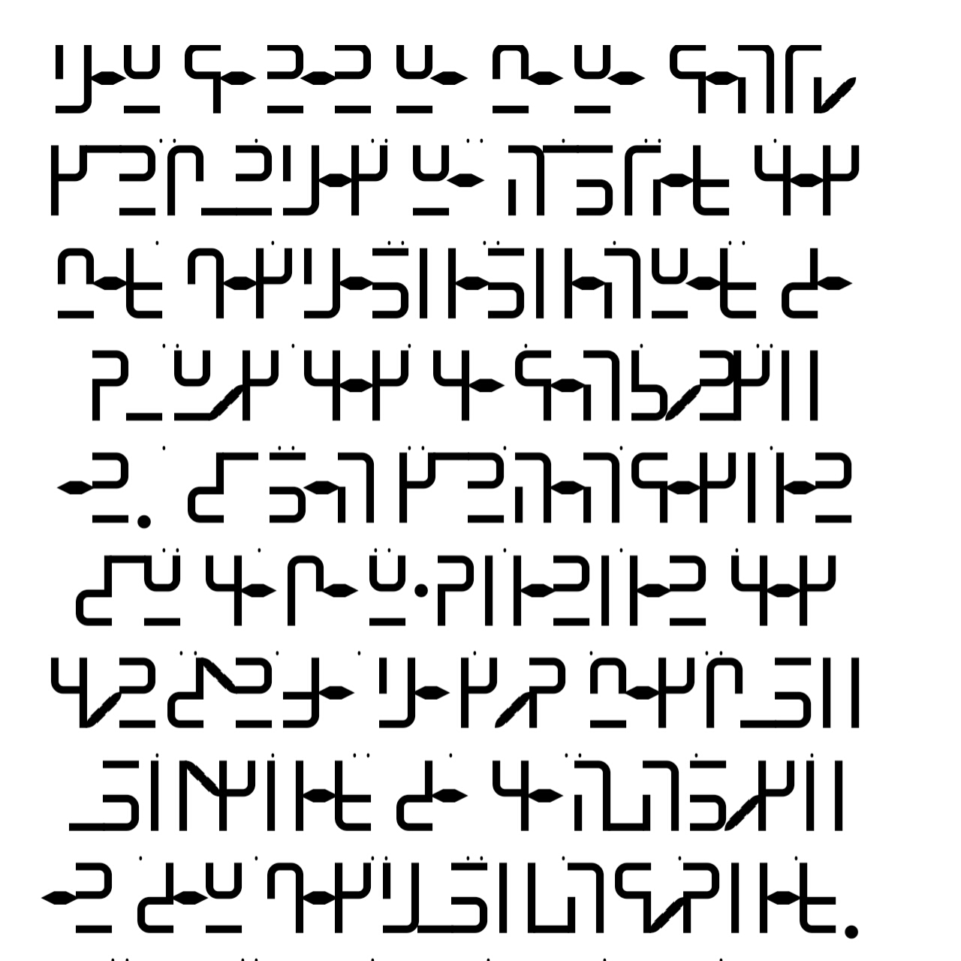
Actual entry when using Hiligaynon keyboard
qañ ta nan ña ma ña tah wo gin bun qag ña hil way kag may pag qal -al -ah ñay sa du ñog kag ka tah roñ -an. si lah gin hah tag -an siñ ka ba ñ'd -an -an kag kon sen Sa qa god mag bul -ul -eg -ay sa ka huh log -an sañ pag qul -uh tod -ay.
Transliteration in Roman alphabet
Ang tanan nga mga tawo ginbun-ag nga hilway kag may pag-alalangay sa dungog kag katarongan. Sila ginhatagan sing kabang'danan kag konsensya agod magbululigay sa kahulogan sang pag-ulutoray.
Translation in English
All human beings are born free and equal in dignity and rights. They are endowed with reason and conscience and should act towards one another in a spirit of brotherhood.
(Article 1 of the Universal Declaration of Human Rights)
If you have questions about this script you can contact Julius at mailto:juliusdalum@yahoo.com and mjuliusdalum87@gmail.com
For Sulat Hiligaynon ttf please download this https://fontstruct.com/fontstructions/show/2234866/sulat-hiligaynon

